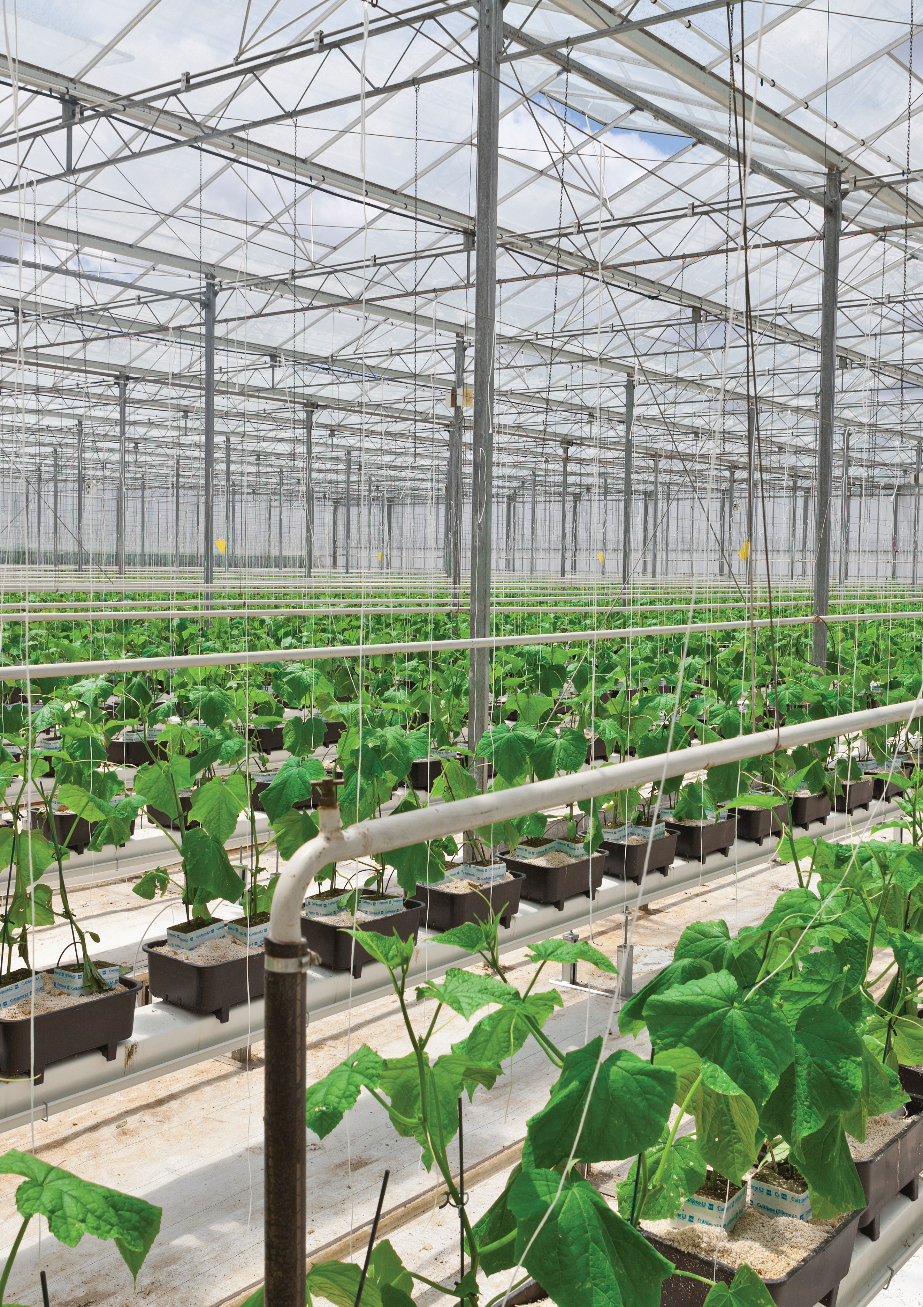



MG Charitable Trust
RABOBANK FARM MANAGERS PROGRAMME
Grower Education Fund
The MG Charitable Trust (MG Trust) is subsidising one place on the 2026 course, valued at $6,000.

About the programme
The programme is an opportunity to learn from experts and network with leading growers and farmers from across Australia and New Zealand. It aims to:
- Further develop management and leadership skills.
- Improve your communication and influencing skills to provide input on business decisions
- Improve your efficiency through time management
- Learn how to develop a business plan
- Understand the essentials of financial management and budgeting

Date: Sunday 14 - Friday 19 June 2026
Location: Victoria, Australia
Attendees are required to have at least three years’ experience.
The course cost is $7,600.00. Applicants who secure a place are required to pay the
$1,600.00 balance and cover travel to and from Victoria. All other costs are covered, including accommodation, meals and transfers.
More information can be found on the Rabobank website - https://www.rabobank.co.nz/agribusiness/business-management-programs/

Who can apply for the $6,000.00 subsidy for the upcoming Rabobank Farm Managers Programme?
The Trustees encourage current growers and their employees to apply if they have been in a management role for more than three years and would like to increase skills in leadership, business planning, people management and financial analysis.
Tertiary qualifications are not a prerequisite for the programme.

How do growers and their employees apply for the subsidy?
Complete the application form and supply a short (one to two page) overview covering how you believe the programme will be of benefit to you and the growing operation you own/ work for. Also include information about your experience to-date, where you want to be in 3-5 years and outline the major issues you currently face in your role.
The deadline for applications is the 13 March 2026.




MG Charitable Trust
Rabobank Farm Managers Programme Grower education fund
Date: Sunday 14 - Friday 19 June 2026
Location: Victoria, Australia

Application Form

Title:
First and last name:
Name of growing operation:
Address of growing operation:
Mobile number:
Email address:
Business website:
Age: | ☐ | ☐ | ☐ | ☐ | ☐ | ☐ | ☐ | ☐
Age: | 21-25 | 26-30 | 31-35 | 36-40 | 41-45 | 46-50 | 51-55 | 55+

Referee - Applicants are required to provide contact details for one referee. Employees applying for the subsidy should use their manager. For business owners applying, you may use someone from inside your business, another grower or a local leader in your product group.

Name of referee

Job title:
First & last name:
Mobile:
Email:

Outline why would you like to attend this programme:

Click or tap here to enter text.

Outline where you want to be in 4-5 years:

Click or tap here to enter text.

Outline the current issues faced in your role:

Click or tap here to enter text.

Outline how you believe this programme will benefit you and the growing operation you work for:

Click or tap here to enter text.

I understand that if this application for the $6,000.000 subsidy is successful and I’m approved for a place on the programme, myself or my employer is required to pay the balance of the fees and cover travel costs to and from Victoria (accommodation is covered as part of the course).
☐YES

NOTE: The MG Charitable Trust has a limited budget. The level of requests is likely to exceed places available across the Grower Education Fund, therefore, strong applications that meet the MG Trust assessment criteria may still be unsuccessful.

Please email your application to mgtrust@mggroup.co.nz before 13 March 2026. While the form is expected to cover the necessary information, the MG Trust may request additional detail.
Applicant information will be stored and managed in accordance with the MG Privacy Policy (available on the MG website).

